A draft North East Community Led Housing Development Strategy
Mainstreaming Community Led Housing
March 2018

3. What is the North East Community Led Housing Development Network?

3.1 The North East Community Led Housing Development Network was established in 2011 by a coalition of community organisations, public sector bodies, housing associations and academic institutions, all with a direct interest in community-led housing. It is currently the only regional community led housing network in the UK.

3.2 The Network has 168 members on its database of whom around 40 are active participants, including three local authorities. It holds quarterly meetings throughout the region, attended by 25-30 individuals, organised by a Steering Group of CLH practitioners, local authorities and housing associations.

3.3 The Network also runs regular seminars, which have included CLH finance, CLH in rural communities and urban CLH schemes.

3.4 Having been administratively supported since its inception by Homes England, the Network is now fully independent and serviced by Community Action Northumberland, a Rural Community Council, with funding raised largely from Network members. Senior representatives of Homes England do, however, continue to be actively involved in the Network.

3.5 The members of the Network look to deliver community led housing across the region, to sustain communities in both urban and rural places where affordability and/or failing markets are key issues. In both situations the challenges can be great, but through the experience shared by the Network we have been able to capture the many opportunities to drive delivery.

3.6 The Network is building on a rich history of community led housing activity in our region, much of it focused on housing co-operatives developed in the 1980s and early 1990s. 15 co-operatives across the region are managing and maintaining more than 400 homes, developed with government funding during this period

3.7 The more recent successes of community led housing organisations in our region are shown in Figure 1. Those highlighted with an asterix have featured in both regional and national publications and one (SCATA) has received a national housing award.

Figure 1: Recent, successful community led housing development across the North East and Tees Valley

Community Organisation | Successes to date
Allendale Community Housing | 3 new build homes with £185,000 of funding through Homes England
Back on the Map, Hendon, Sunderland* | 72 ‘at risk’ properties purchased from private landlords and owner occupiers and then refurbished in Hendon, using a £3.5 million renewal programme. Negotiations underway to transfer a further 130 properties from a housing association to the community-led organisation
Bomasund Housing Co-operative | Owns and manages 164 homes in Blyth, Seghill, Ashington, Stakeford and South Shields. 12 new 1 and 2 bed apartments for affordable rent have recently been completed with Homes England funding
Community Campus 87 | 64 homes refurbished across Teesside mainly for young people, with £1.2 million of Empty Homes funding
East Cleveland Youth Housing Trust | 14 properties refurbished across East Cleveland with £114,000 of Empty Homes funding
Five Lamps, Stockton | 49 empty homes (with 121 bedspaces) refurbished and brought back into use across County Durham and Darlington with £1.3 million of Empty Homes funding
Glendale Gateway Trust, Wooler* | Owns and manages 18 affordable homes. 9 affordable rented homes refurbished with £350,000 of Empty Homes funding
Haltwhistle Partnership | 4 refurbished flats for rent with £200,000 funding from a variety of local and public sector sources
Hartlepool NDC Trust | £1 million refurbishment of 8 apartments in the former Morrisons Hall in Hartlepool, with £351,000 from the Empty Homes programme
Holy Island of Lindisfarne Development Trust* | 9 houses and 2 flats for affordable rent built in two phases with Homes England funding of £212,000 for the second phase
Jewish Community Council of Gateshead | A £1.9 million development of 12 new 5 bedroom houses for affordable rent, built in Bensham with Homes England funding
Middlesbrough CLT | 3 properties acquired in Gresham from Middlesbrough Council for £1 each and renovated with Empty Homes Programme funding
North Ormesby Neighbourhood Development Trust, Middlesbrough* | 6 empty homes transferred from a housing association and refurbished by the local North Ormesby community at a total cost of £225,000, funded by Homes England and Big Local
Prudhoe Community Partnership | 2 new affordable rent 1 bed flats built in Prudhoe with Northumberland County Council and Homes England funding; 8 more in the pipeline, both in partnership with Karbon Homes
Stocksfield Community Association Trading Arm (SCATA)* | Affordable rent new build scheme of 4 flats and 3 bungalows, £930,000 capital funding, with key partners including Karbon Housing, Homes England, Northumberland County Council and Broomley and Stocksfield Parish Council

3.8 In summary, over the past 5 years, these successes amount to:
- More than 50 new community-led homes built for affordable rent;
- 229 empty homes brought back into use by community-led organisations;
- Approximately £10 million of public investment in community led housing in our region;
- Important community partnerships established with three housing associations;
3.9 Figure 2 shows 51 community-led organisations across the region that have either developed housing schemes in the past, are considering doing so or are working on specific projects during 2018.

3.10 Members of the North East Community led Housing Development Network have been closely involved in national work to scale up the sector and secure support for it from more local authorities, housing associations and their development partners. Two important outcomes of this work are the Co-operative Councils’ Innovation Network’s Commission on Co-operative and Community-Led Housing (December 2017) and the HACT Community-led Housing Technical Toolkit (March 2018). Both contain a large amount of information on how local authorities and housing associations are already helping to scale up community led housing and how others might follow suit.

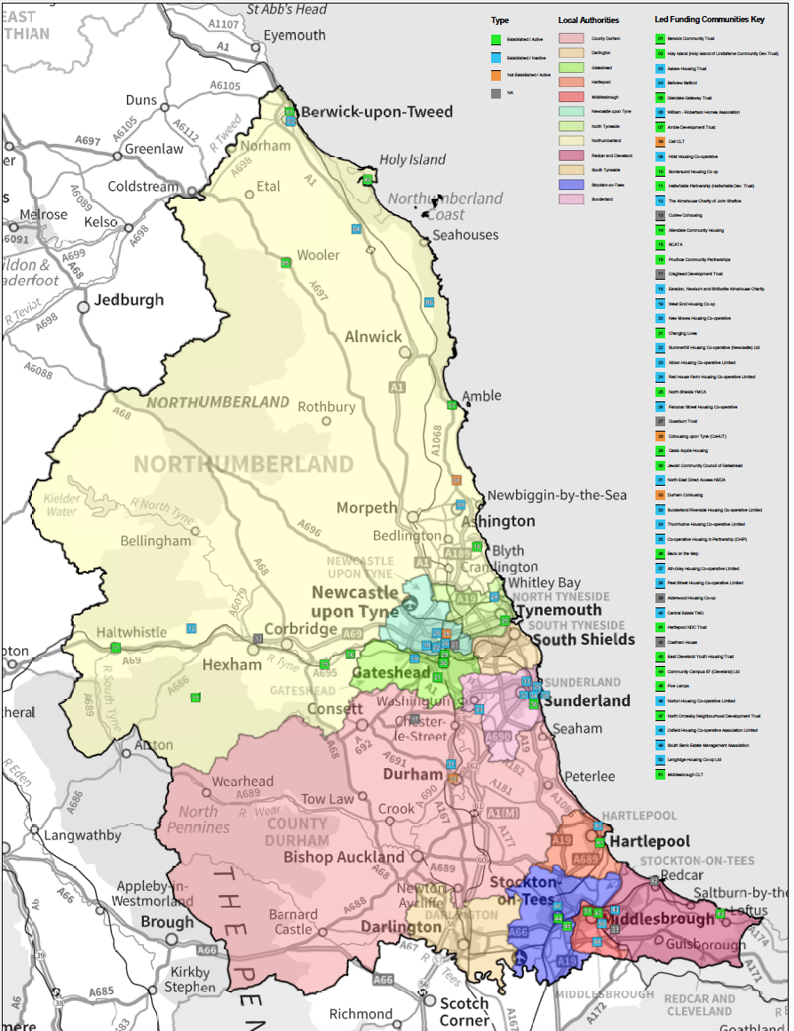

4. What is this strategy all about?

4.1 This document offers something different. It is a strategy, created by the Network, to not only promote the work that has gone before but also to explore and set out the future ambition for community led housing development in the region.

4.2 This is a hopeful and exciting time for proponents of community led housing. Our regional track record, coupled with the Government’s recently launched Community Housing Fund (£60m per annum funding) has provided a new and significant platform for the growth of the sector.

4.3 The first year of the Community Housing Fund was allocated to 148 local authorities, focused on those with significant amounts of second home ownership. Northumberland was the only local authority in the region to benefit from this initial round, receiving £1.3 million. The next two years of capital funding and project-specific revenue support (£120 million) is to be administered by Homes England and will be more broadly focused and subject to a competitive bidding process.

4.4 Separate revenue funding will be available for developing the national network of CLH support hubs, complementing Lottery funding made available in Bristol and Leeds through Power to Change. We expect some of this funding to come to our region where our only support hub currently is in Northumberland.

4.5 Set alongside Homes England’s £9 billion Shared Ownership and Affordable Housing Programme (SOAHP), the progress made with devolution within our region, and the central Government ambition to build 300,000 homes per annum by 2021, means that it is undoubtedly the right time to set out a route map to scale up and harness the great potential of community led housing in the North East and Tees Valley.

4.6 This strategy therefore sets out where we are today, where we want to be and the challenges that community led organisations may face in the process. It establishes the argument for community led housing development as a mainstream form of delivery that should be seen as one of the many routes to meeting the Government’s housing ambitions set out in the 2017 Housing White Paper.

4.7 Most importantly the strategy sets out our vision through five ’BIG ideas’. These ideas will help to focus minds and capture imaginations. However, in order to realise these ‘BIG ideas’, we need to outline the steps we all need to take. The strategy therefore describes what the community led housing ‘offer’ looks like and lists the ‘asks’ that the Network would like our public and private sector partners to sign up to.

What are the BIG Ideas?

4.8 The Network believes that public, private and third sector collaboration can help to realise five ‘BIG Ideas’ that will help to grow the next generation of community led housing and bring about long term sustainability for communities in areas that face affordability challenges and those in failing markets. Our five ‘BIG Ideas’ set out what we would like to explore further to extend our reach, influence and impact:

Figure 3: The Five ‘Big Ideas’

Five ‘BIG Ideas’
1 - ‘Create the Hubs’
Establish two Community Led Housing Enabling Hubs (CLHEHs), one in the North East and one in Tees Valley, that will provide face-face support for local groups wanting to provide community led housing, offering peer support, technical advice and best practice sharing

2 - ‘Keep it local’
Prove that local relationships, networks and community influence can open up opportunities that otherwise remain closed

3 - ‘Make it less scary’
Build on best practice to show how community led housing development can be progressed and work to de-risk the development process for emerging community organisations

4 - ‘Help us to help ourselves’
Explore ways that communities can raise some of their own funding, e.g through crowd funding and unlocking the equity within existing community led housing schemes to be recycled into new schemes and enabling work

5 – ‘Secure high-level supporters’
Get support and commitment to the strategy at the highest level from council leaders, chief executives and other senior housing stakeholders, through an agreement to work jointly on delivering community led housing across the region

What will this look like in 5 years’ time?

4.9 These ‘BIG Ideas’ will help to achieve the following goals within five years’ time:
- Every Local Authority will be signed up to this strategy and will have a named Community Led Housing Champion within both the senior officer staff team and amongst the councillors;
- Every housing development in the North East and Tees Valley of more than 20 homes will include an element of community led housing;
- Every community across the region will have access to a community led housing support hub;
- Every member of the Homes England North East Yorkshire and the Humber Delivery Team will have an understanding of community led housing and the opportunities it can bring for Homes England sites and the strategic deployment of the Community Housing Fund;
- Every SME and large house builder in the North East and Tees Valley will work with the Network and Hubs to identify opportunities for community led partnership and development;
- Every large land owner in the North East and Tees Valley will work with the Network and Hubs to identify opportunities for community led land acquisition and development; and
- Every large Housing Association or consortium in the North East and Tees Valley will have a community led housing champion and will be engaged with the work of the Support Hubs and the Network.
4.10 As a result of these partnerships and the progress made in increasing delivery, the North East and Tees Valley together will be recognised as a Centre of Excellence for Community Led housing development.

The Offer

4.11 We know where we want to be, but the task is getting there. The road from community group inception to the cutting of a ribbon is a long one and we all recognise that to date there have been a number of challenges to overcome. The key challenges that we need to collectively tackle are set out below.

Figure 4: Key Current Challenges to Scaling Up Community Led Development

What can the Network offer?

4.12 The Network has a seven point ‘offer’ that we hope will meet some of the challenges set out above. In addition, we hope they will motivate and inspire other partners to agree a set of housing sector ‘asks’ to promote and enable community led development delivery.

4.13 The Network offer includes:

- Using the experience and learning from Communities CAN Northumberland and emerging hubs elsewhere in England to explore and prove the merits of the creation of two new geographically based Community Led Housing Enabling Hubs in our region – one in the North East and the other in the Tees Valley. We need to demonstrate how the Hubs can drive delivery without becoming another layer of bureaucracy or taking revenue investment away from local communities or the community led housing sector.

- Designing a business plan for establishing and identifying funding for these two Community Led Housing Enabling Hubs to support community organisations through the 5 main stages of the process for delivering community led housing:

- Group formation;
- Finding and securing a site, assets and/or empty homes;
- Homes England Registration (where appropriate) with governance and legal advice;
- Planning, designing and financing the scheme;
- Building out the scheme; and
- Long-term management and maintenance of the scheme.
This support will take the form of: signposting, peer-to-peer support, mediation, brokering, technical advice and ‘seeing is believing’ best practice opportunities. This will take the pressure away from already stretched teams within local authorities and offer opportunities for housing associations who have in the past seen community led housing as being too labour intensive. The Hubs can offer the ‘hand holding’ that may put potential partners off and can also show how housing associations can meet their social aims through such partnerships.

- Designing and encouraging the signing up to a formal agreement between the two Hubs and key partners, particularly local authorities and housing associations to ensure that there is a clear understanding of the roles of the respective organisations and to secure ‘buy-in’ from local partners by introducing a means of holding all partners and the Hubs to account.

- Creating a political engagement strategy in order to nurture and encourage local political support, particularly those that have influence and shape strategic direction and policy. The Hubs will factor into their budgets the time and resources needed for working closely with local politicians, alongside wider promotional activity that celebrates success.

- Making an offer to work with local authorities to pick up enquiries from their self-build, custom build and community led development registers to promote and start the conversation with interested parties. This will support the work of councils and reduce the pressure on their teams to respond to all enquiries.

- Identifying land opportunities for all community organisations and their partners. Through the creation of the two Hubs the Network will offer support in land finding through liaison with private land owners, Homes England, local authorities and others to assist with the acquisition of sites, particularly where developers, including housing associations, may be less likely to become involved.

- Working closely with national CLH organisations, primarily the National Community Land Trust Network, Locality, Cohousing Network, National Housing Federation, Self Help Housing, and the Confederation for Co-operative Housing to enable the Hubs to share and signpost external sources of support to extend the advice and funding opportunities on offer to all partners and community groups.
Our Asks

4.14 We have set out what the Network will do to bring about our five ‘BIG Ideas’ and our vision for community housing in five years’ time.
The Network sees the potential for change and has articulated its ambition. Below in Figure 5 we have set out our ‘asks’, addressed to each of our key partners. The ‘asks’ are what we hope our partners can do in return to bring about a ‘step change’ in delivery rates and the growth of a next generation of community led housing.

Figure 5: Our ‘asks’

Key Partner | ‘Asks’ from the Community Led Housing Development Network
- LA Directors of Place and Combined Authority Housing Leads | - Identify a senior officer to act as Community Led Housing Champion;  - Agree to quarterly meetings between the Champion and the relevant local Hub to discuss opportunities;  - Ensure that the Champion works to inform, educate and guide colleagues in all areas of LA work i.e. legal, assets, housing and planning teams;  - Agree to work with the Network and Hubs (once established) to identify opportunities from the Self Build, Custom Build and Community Led Registers;  - Cite community led opportunities in housing strategies e.g. affordable housing delivery or tackling empty homes;  - Commit to review sites to assess their suitability for community led housing and consider how planning policy can make provision for community led housing schemes e.g. allowing development on rural exception sites with the presumption that it is to be community-led,  - Agree to exploring how community led housing could support the issue of ‘downsizing’ and generational housing need, particularly in rural areas;  - Offer a route to increasing the opportunities and time for community organisations to bid for and acquire publicly owned land and buildings, helping to diversify the local housebuilding market, unlocking small sites not attractive to mainstream developers;  - Agree to involve the Network and the Hubs in the neighbourhood planning process;  - Agree a route for the Hubs (once established) to be informed of sites that are working their way through the planning process, that could be suitable for an element of community led development. OR If brokering is required for a developer to find end users for affordable units on a development.  - Consider the potential for using capital receipts, borrowing under the Prudential Code and establishing revolving loan funds to support community-led housing schemes
- Council Leaders and Cabinet Members | - Identify a cabinet member to act as Community led Champion;  - Work with the Network and your local Hub (once established) to better understand the role and value of community led development - ‘what’s not to like’?  - Seek opportunities to identify and support emerging community groups and use the Network and Hubs to sign post support;  - Encourage and support planning applications which include an element of community led housing development.
- National Housing Federation | - The National Housing Federation and the Network are asked to work closely together to understand and articulate their joint approach to supporting community led housing. Regular meetings and a close working relationship will allow joint learning and agreement of practical steps to identify and accelerate development opportunities.
- Housing Associations | - In partnership with the Network, explore local examples and those from across England to share experiences of how community led development can and should be seen as a ‘business opportunity’;  - For housing associations that have worked with community led organisations, act as ambassadors for the sector;  - Commit to exploring the opportunities of a range of tenures including shared ownership within community led housing developments and opportunities for older persons housing  - Commit to considering community led as a solution to long standing issues e.g. voids or stock disposal, using tenants associations and local community groups to empower, motivate and communicate opportunities for rural or urban populations.
- Land Owners and the Country Land Owners Association | - Agree to raise awareness of community led development within your teams and work with the Network / Hubs to design learning opportunities;  - Regularly share with the Network and Hubs any lists of planning obligations and affordable housing opportunities that housing associations have turned down. Consider whether a community organisation with the support of a Hub and the Network could take on affordable housing units;  - Agree to an annual meeting with the Network or the Hubs to ensure that relationships are maintained and joint priorities are agreed.
- House Builders | - Agree to raise awareness of community led housing development within your teams and work with the Network / Hubs to design learning opportunities;  - Consider whether a community organisation with the support of a Hub and the Network could take on affordable housing units as part of private developments; and  - Agree to an annual meeting with the Network or the Hubs to ensure that relationships are maintained and joint priorities are agreed.
- Homes England | - Homes England to continue to work with the Network, the Hubs, and other partners to explore funding opportunities through the Community Housing Fund and complement the work of the larger housing associations funded through the Shared Ownership and Affordable Housing Programme (SOAHP);  - Homes England to assess when and how community led housing may be developed on its own sites brought to the market, including other Government Department’s sites that are to be transferred to the Agency.  - Homes England to assess the profile given to community led development through Investment Partner briefings, Partner Events and Contract Review Meetings.  - Homes England to consider the use of Development Partner Panel 3 (DPP3) procurement to promote and increase opportunities for an element of community led housing.
8. Key funders | a) Establish a panel of community-led housing funders, including Virgin Foundation, Nationwide Foundation, Charity Bank, Triodos, Ecology and Esme Fairburn and others as appropriate.

What Next?

4.15 The Strategy summarises the value of community led housing and offers a vision for where we want the sector to be in five years’ time. In the North East and Tees Valley we have the ingredients for a thriving community led development sector. We have had great success to date, the opportunities are significant, but the challenges remain.
The ways in which we can overcome these challenges and collectively bring about a step change in delivery have been outlined. All of the major players and key partners have been included. Each has a series of ‘asks’ to sign up to.
The first step in this process is the creation of the two geographically based Community Led Housing Enabling Hubs and this strategy sets out the ways in which the Hubs will be a catalyst for further growth in the sector.
Once the Network has consulted on this strategy we will produce a detailed Action Plan for the two Hubs and secure the commitments that have been set out in this document to deliver a significant community led housing programme across our region.

